1. You are working in an e-commerce company and need to design a flowchart for processing an online

order. The flowchart should include process modules for each step involved in handling an order and

decision structures to handle stock availability and payment verification.

READ CUSTOMER NAME, PHONE NUMBER ADDRESS

READ ORDER

SELECT PAYMENT METHOD

READ ITEM, NumberOfItem

IF PAYMENT METHOD IS CARD

CHOSE ANOTHER PAYMENT METHOD

NONO

IF ITEM IS AVAILABLE

NO

PRINT ITEM IS OUT OF STOCK

YES

IF AMOUNT RECEIVED= TOTAL AMOUNT

YES

READ CARD DETAILS

NO

TOTAL AMOUNT= NUMBER OF ITEMS\*PRICE OF ITEM

IF AMOUNT RECEIVED= TOTAL AMOUNT

NOo

YES

YES

PRINT PAYMENT RECIEVED

LAB TASK

1. Find if the number is multiple of 5.
2. START
4. INPUT number
6. IF (num is divisible by 5) then
7. PRINT "num is a multiple of 5."
8. ELSE
9. PRINT "num is not a multiple of 5."
10. Check if a character is uppercase or lowercase

1. START
3. INPUT character
4. IF character≥ “A” AND character≤ “Z” THEN;
5. PRINT “UPPERCASE”
6. ELSE IF character≥ “a” and character ≤ “z” THEN;
7. PRINT “LOWERCASE”
8. Create a small calculator which only does ‘+’ or ‘\*‘Operations. (Hint: Take three variable inputs with one being used for the operator)
9. INPUT number1, number2, operator, sum, product
10. IF operator == ”+” THEN;
11. Sum= Number1+ Number2
12. PRINT Sum
13. IF operator == “ \* “ THEN;
14. Product= Number1\*Number 2
15. PRINT product
16. ELSE:
17. PRINT “unidentified operator used”
18. END
19. Check whether a given number is positive, negative, or zero.
20. INPUT num
21. IF num>0
22. PRINT “Positive”
23. ELSE;
24. IF num<0
25. PRINT “Negitive”
26. ELSE;
27. PRINT “Zero”
28. Determine if a person is a teenager (between 13 and 19 years old).
29. INPUT age
30. IF AGE >= 13 AND <= 19 THEN;
31. PRINT “You are a teenager”
32. ELSE;
33. PRINT “you are not a teenager”
34. END

Lab task 2

1. Implement an algorithm to determine if a given year is a leap year. A leap year is divisible

by 4, but not divisible by 100, except if it is also divisible by 400.

1. INPUT year
2. IF year MOD 4==0 AND year MOD 100<>0
3. PRINT “Leap Year”
4. ELSE if Year MOD 400==0 THEN;
5. PRINT “Leap Year”
6. ELSE:
7. PRINT “Not a leap year”
8. END

2. Implement an algorithm to count the number of occurrences of each character in a given

string.

1. Ask user to enter string
2. Initialize a list or a dictionary to store characters and their counts.

3. For each character in the string:

• If the character is already in the object, increment its count.

• If the character is not in the dictionary, add it with a count of 1.

4. Display the object with each character and its corresponding count for the user.

3. Write an algorithm to calculate x raised to the power y (i.e., x y ) without using built-in

power functions.

1. Begin with the result set to 1
2. Multiply the result by x as many times as y
3. After looping through, the result will be xy

4. Calculate the area of a circle given its radius r.

1. Input radius ‘r’ of circle
2. Set value of pi as approximate 3.14159
3. Area= pi \* r \* r
4. Output the calculated area
5. END

5. Find the median of three given numbers.

1. Input numbers ‘A’ ‘B’ ‘C’
2. Compare the numbers provided
3. IF (A≥B≥C) OR (C≥B≥A) B is the median
4. IF (B≥A≥C) OR (C≥A≥B) A is the median
5. Else C is the median

Lab Task 3

1. Create your repository with your roll number being your repo name

2. Upload the algorithms and pseudo codes in your repository

3. Create a small intro about yourself in the readme file with pictures and bullet points

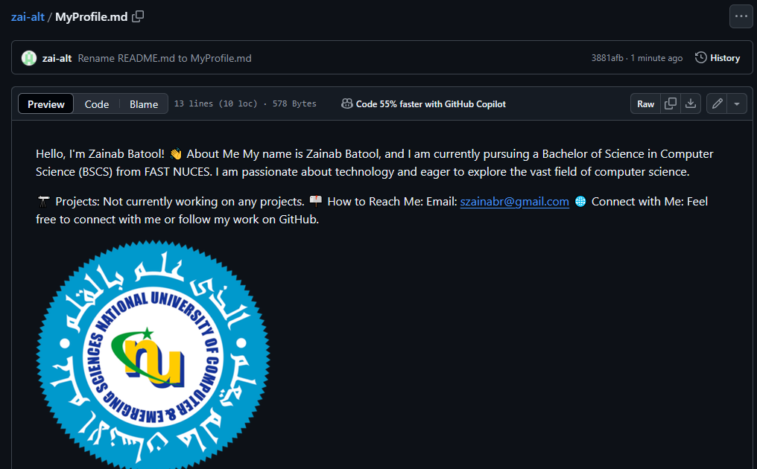

<https://github.com/zai-alt/zai-alt/blame/main/MyProfile.md>